**Utilization of Softbody Locomotion with Deep RL(FEM)**

Hanyang Univ. Computer-Software Engineering Department

Graduate Project Team 8

Hwan Jin, Kim

**Introduction**

Our team have planned a lot of time how to utilize our project studies on real-world. But, it was too vague to apply this mechanism on practice problems because there are not sufficient domain which it can be used. We considered practicality about all things produced our efforts. We wanted that our project would be worth on the world, and used widely. We constantly found subjects that our project can be applied for, by crawling Internet, reading wiki, and interviewing. Then, We constructed categories of subjects that we found and classified categories we can do that during this semester or cannot. It was future robot technology and biology that we decided representative categories on previous step.

**Proposal : Biology**

From now on, All things that will be described in this paper are My opinions not Ours. I thought that it was better idea that we handle biologic idea rather than future robotic tech or science because of vague insight of domains. Although we could get information about some robotics which mentioned softbody dynamics e.g. American Military Science, Future softbody robot scanning defects on pipe (gas, liquid) etc, we just figured out it presented just little insight about our project way to go. So, I caught some inspiration through consulting my acquaintance who specializes biology. He gave me some biologic idea that this area request to computer science.

**Caenorhabditis elegans And Open Worm**

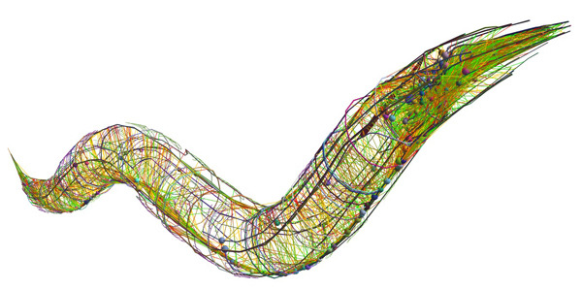

I heard about Caenorhabditis elegans which have took core role in brain/neural science. Although these worms are classified softbody creatures, I will not follow these creatures. But We can try some researches similar with Open Worm which simulates Caenorhabditis elegans’ motions. I inspired when trying to search some information about these creatures, which is eaten by white blood cells. It was white blood cells that I finally inspired for the way of our project.

**leukocyte**.

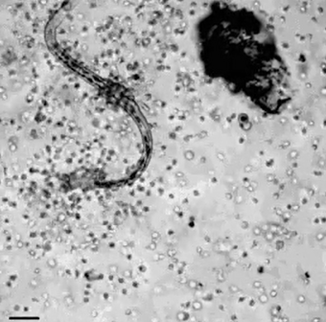

Leukocytes eating Caenorhabditis elegans

These cells move following ameba movement, which is not known exactly but based on softbody locomotion(contracting and expanding). It constitutes our bloods but behave individually when hunting antigens which flowed into our body(bacterium, viruses, other microbes.). So, It will be useful achievement that we research these phenomena, and give some insight of these biologic principles to medical sciences or bio-technologies. It seems simple because It don’t need high graphic materials, a lot of environmental interactions, deep knowledge about biology. I think it is helpful for our project that making a model of Open Worm when we advance our simulations using FEM.

In the future, human beings will control antibody or nano-robot acting like that, or create artificial creatures. Our research can contribute for realization those technology.

**Epilogue**

Thank you for reading this paper. Saying that again, it is just my opinion not our team. So, After sufficient talking about our project direction, then getting some advices for advancing our project in proper way, finally we will decide carefully.